Final year Project Proposal

**Sayahat: A Tourism Website**

Submitted By

Syed Muhammad Arfa 17-SE-38

Muhammad Wajih-ur-Rehman 17-SE-72

Ayesha Hameed 17-SE-24

Supervisor

Engr. Mubashir Ayub



Assistant Professor

DEPARTMENT OF SOFTWARE ENGINEERING

FACULTY OF TELECOMMUNICATION AND INFORMATION ENGINEERING

UNIVERSITY OF ENGINEERING AND TECHNOLOGY TAXILA

July, 2021

Contents

**Chapter 1** 3

**1.** **Introduction:** 3

**1.1** **Project Goal** 3

**1.2** **Aims & Objectives** 4

**1.3 Deliverables** 5

**Chapter 2** 6

**2.** **Literature Review** 6

**2.1 Literature Survey** 6

**2.2 Market Survey** 6

**Chapter 3** 9

**3.** **Methodology** 9

**3.1 Detailed Methodology Used with Block and Flow Diagrams** 9

**3.2 Project timeline** 16

**3.3 Experimental/ Simulation Setup** 18

**3.4 Details of Work packages completed/milestones achieved** 18

**3.5 Evaluation parameters** 20

**Chapter 4** 21

**4.** **Results and Discussion** 21

**4.1** **Simulation Results** 21

**4.2** **Product Demo** 22

**4.3** **Results Discussion** 27

**4.4** **Utilization (End users/Beneficiaries)** 27

**4.5** **Budget Used** 29

**4.6 Market forecasting** 30

**Chapter 5** 31

**5.1 Conclusion** 31

**5.2 Prospects** 31

**6. References** 32

# **Chapter 1**

# **Introduction:**

A Web based portal to be known as ‘SAYAHAT’, for boosting the tourism sector of our country. We are building the portal to make it a productive asset for our nation. SAYAHAT will be a tourist portal, where international and local tourists can get information about popular or hidden beautiful locations of Pakistan. Secondly, the portal would be able to provide information about food points, hotel accommodation, and local tourist spots of a city. For example, Murree is a good point for tourists, but is there any specific local tourist spot? Yes, there is! One of them is ‘Kashmir Point’.

Tourists have a problem of finding different spots or locations, because there’s no active website or app in Pakistan that can help them have info about the majority of fantastic places of Pakistan. The motto of our website is to make it easy for people to find tourist spots.

Pakistan is well equipped with diverse landscapes and we often ignore them because of less knowledge about landscape of Pakistan. So, ‘SAYAHAT’ web portal will give detailed info about places, with images, content, food, and tourists review based suggestions to people.

One of the important aspects of ‘SAYAHAT’ is to enroll adventure clubs with it. The adventure clubs, that book people and carry them to the beautiful places of Pakistan. These clubs can register with ‘SAYAHAT’ and can upload their events, so that people can book their seats in currently active event, and enjoy tour with friends and family.

### **Project Goal**

The goals for ‘SAYAHAT’ are divided into two categories:

1. The short-term goals of project include, achievement of desired project functionality, usability, efficiency, marketing of project, and simplicity.
2. The long-term goal of ‘SAYAHAT’ is concerned with promotion of tourism across Pakistan and on international level, as well.

### **Aims & Objectives**

The aims and objectives of ‘SAYAHAT’ can be explained in terms of scope, time, cost, etc. These objectives are

|  |  |  |  |  |
| --- | --- | --- | --- | --- |
|  | **Scope** | **Time** | **Cost** | **Other** |
| **Aims and Objectives** | 1. Nation-wide promotion of tourism 2. Focus on international tourists 3. Providing knowledge and facility accommodation to a tourist 4. Involvement of adventure clubs, so as to help them and the people to arrange trip easily | 1. Estimated time for completion of project must not be exceeded more than 4 months 2. Launching the web portal within the given time limit | 1. Cost associated with project development will not increase more than $300 | 1. All the features of ‘SAYAHAT’ must be according to the requirements   as discussed with stakeholders |
| **Success Criteria** | Fulfillment of all the requirements and features, as well as the deliverables specified, while keeping an eye on performance and efficiency of the system | Progress of the project will be tracked on weekly basis and compared according to the planned duration | Completion of the project within specified cost constraints | Agreed project functionality |

### **1.3 Deliverables**

* In first phase, complete SRS document is delivered that will show all the requirements of the project, the work formula and the brief overview of the project functionality with the help of essential diagrammatic representation of system such as Class Diagram, Use Case Diagram, Sequence Diagram, etc.
* In second phase, the web portal will be launched that will be in conformance to the agreed set of requirements after thorough testing and a robust server would be purchased with a domain, the website will be live and can be accessed from anywhere, anytime.
* The third phase will be concerned with maintenance of the portal. The additional functionality will be added to the portal according to the needs and demands of the people using our services.

# **Chapter 2**

# **Literature Review**

The literary review of ‘SAYAHAT’ will be discussed in this section:

### **2.1 Literature Survey**

As according to the recent reports and surveys, the tourism in our country is increasing. The tourism industry is one of the growing industries of Pakistan. Our country is extremely diverse both ethnically and geographically and also a vast number of cultural heritage and historical sites are present all across the country. The boost in tourism has been aided significantly by the Government of Pakistan’s recent decision that was primarily based on ‘No Objection Certificates’ for tourists visiting from different parts of the world.

Our country can improve the stability economically, by the aid of boost in tourism industry of our country and that is one of the prime factors, that will answer to the question, why have we chosen to work on this topic? Furthermore, these are some of the references from the survey’s or the articles that are highlighting the importance of tourism for Pakistan:

* Recently, Pakistan was being ranked as ‘The Best Holiday Destination’ for the year 2020 by one of the famous and the leading travel magazines [1]
* Pakistan was also ranked as the ‘Third Highest Potential Destination’ of the world [1]
* In the year 2018, Pakistan was given a title of ‘World’s Top Adventure Travel Destination’ by the ‘British Backpacker Society’ [2]
* In the year 2019, Pakistan was ranked by ‘Forbes’ as ‘Coolest Places’ in the world to visit [3]

### **2.2 Market Survey**

While analyzing the market trends of tourism industry of Pakistan, following are the statistics of the conducted surveys

* The direct contribution of tourism to GDP of the country was approximately US$328.3 million in the year 2015 [4]
* The direct contribution of tourism to GDP of the country was approximately US$7.6 billion i.e. (PKR 793 billion) in the year 2016 [5]

According to the recent statements made by PM Imran Khan, he said that, tourism industry has seen an enormous amount of boost in the recent few years, so the protection of tourist sites is necessary, programs titled as eco-tourism are also started for enhancement of tourism across the country while of course, keeping an eye on the tourist sites [6]. So, we can predict that sufficient amount of aid is provided by tourism to the economy of the country. Moreover, it is being said that the tourism industry of Pakistan can grow US $39.8 billion within a decade (WTO) as shown in the below Figure 2.2.1:

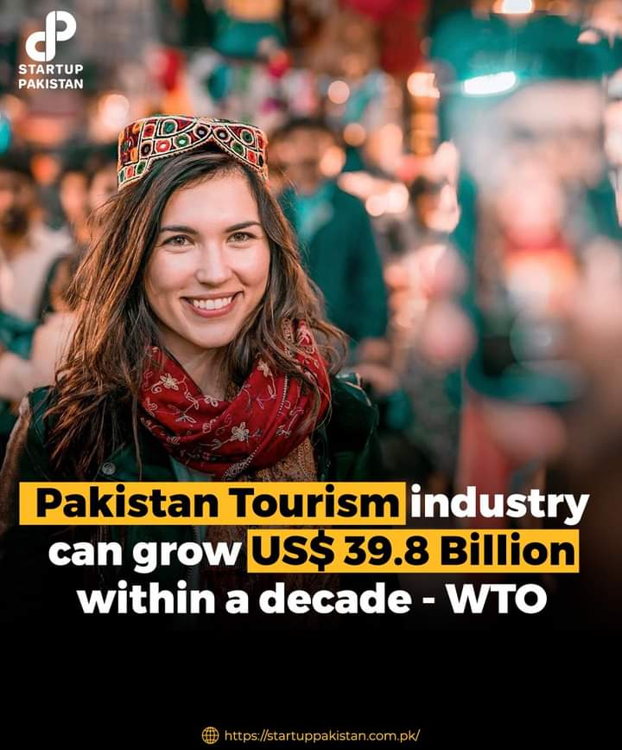

Report by WTO regarding Tourism in Pakistan

**Figure 2.2**

Hence, according to all of these research, promotion of tourism is a big need of today, and hence we are working on this portal to provide an aid to the tourism industry of Pakistan and hance making it a valuable asset for the country and the people.

# **Chapter 3**

## **Methodology**

### **3.1 Detailed Methodology Used with Block and Flow Diagrams**

We are going to use DJANGO framework for back-end and BOOTSTRAP framework for front-end.

In our website, we will be using ITERATIVE MODEL. In this model we focus on starting with some of software specifications and developing first version of software after which if there is any need to change that software then a new version of software is created having new iteration. This model allows us to access the earlier phases in which the changes were made, respectively. At the end of the software Development Life Cycle (SDLC) process the final output of our project is renewed. The project will be initialized with planning, after which we will conduct surveys and interviews to gather information related to what market, tourists and Adventure Clubs want from this system. Then requirements will be set. After this, design of the system will be developed which leads to the implementation of actual system. Then verification will be done by us and evaluation will be done by panel.

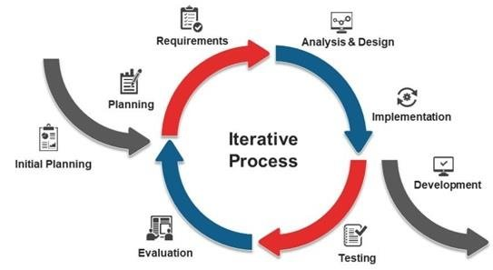

Iterative Process for Development

**Figure 3.1**

* + 1. **Various Phases of Iterative Model**

Following are the various phases of the Iterative Model used in our project:

1. **Requirements Gathering and Analysis Phase**

In requirements phase, requirements are gathered from users and customers and check by an analyst whether requirements will be fulfilled or not. Analyst checks that the need could be achieved within budget or not. After all of this, we shift to our next phase.

1. **Design Phase**

After the requirements are gathered then we need to implement the design phase. Effective design is decided to implement the requirements out of many alternatives. This is one of the critical phases as proper design will provide the most optimal outputs. This design can be a new or an extension to the already build requirement.

1. **Implementation or Development Phase**

The design that was decided in design phase will be implemented by the developer with decided coding and metrics standard. The developer will convert the requirements gathered in coding language and transform into computer programs called software.

1. **Testing Phase**

Once the development phase is completed then this testing phase is implemented to identify any defects that are present in the code and if present then they need to be reported back to the developers. There are different test methods, some most common are white box, black box, and grey box test methods.

1. **Deployment Phase**

After completing all the above phases, software is deployed to the work environment.

1. **Review Phase**

After the deployment phase, review phase is performed to check the behavior and validity of the developed product. And if any errors are found then the process starts again from the requirement gathering.

1. **Maintenance Phase**

In the maintenance phase, after deployment of the software in the work environment there may be either bugs, some errors or new updates required. Maintenance involves debugging and options for new additions.

* + 1. **Class Diagrams**

There are two apps in our project Adventure Club app and Location app so following are the class diagrams.

* **For Location App**

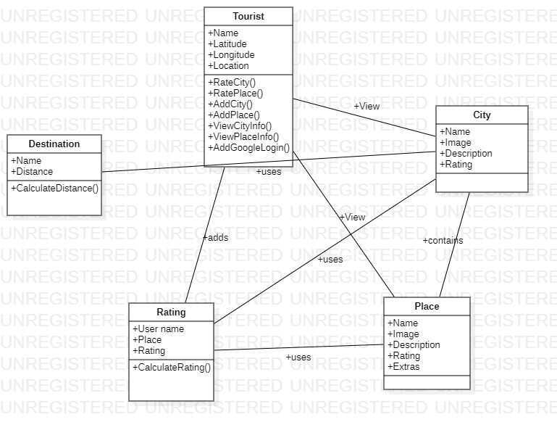

Class Diagram for Location App

**Figure 3.2**

* **For Adventure Club App**

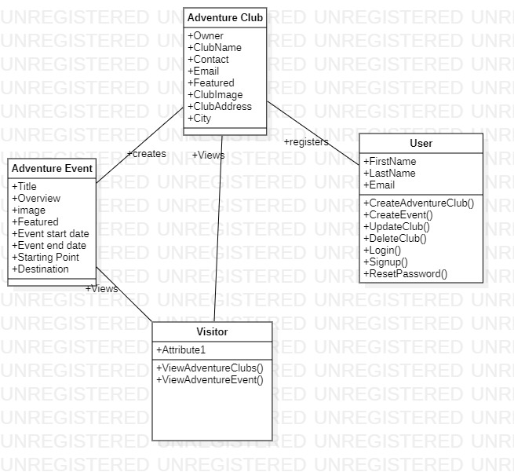

Class Diagram for Adventure Club App

**Figure 3.3**

* + 1. **Use Case Diagrams**

There are two apps in our project, Adventure Club app and Location app, so following are the use case diagrams.

* **For Location App**

Use case Diagram for Location App

**Figure 3.4**

* **For Adventure Club App**

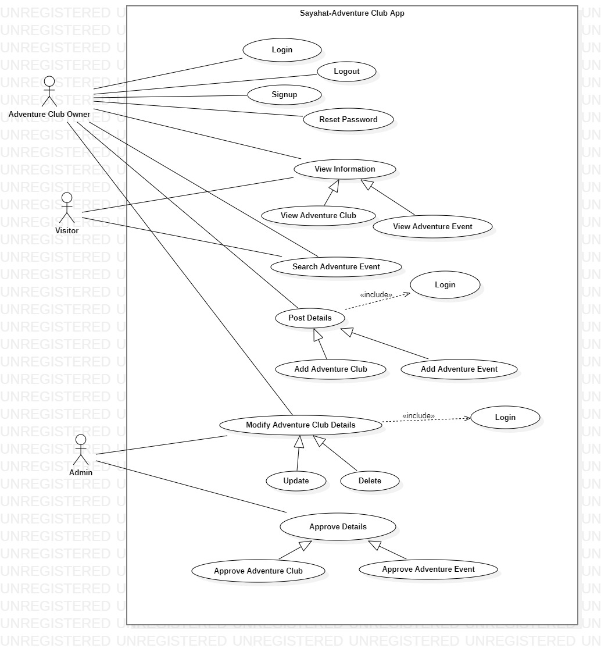

Use case Diagram for Adventure Club App

**Figure 3.5**

### **3.2 Project timeline**

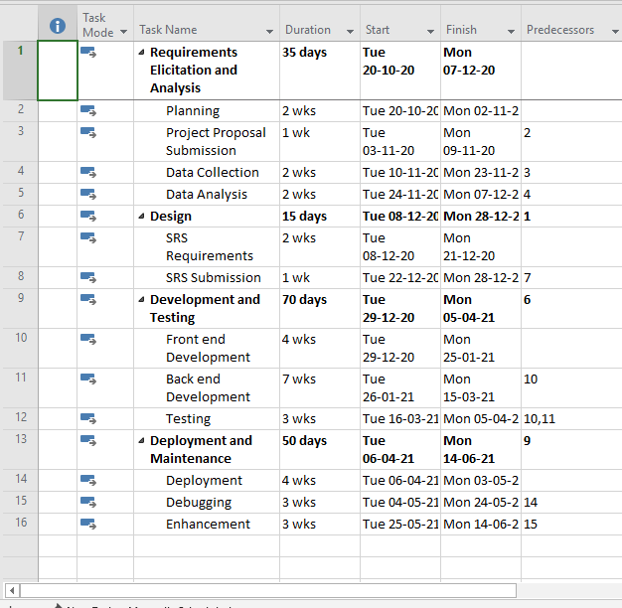

Project Timeline

**Figure 3.6**

**Gantt Chart View**

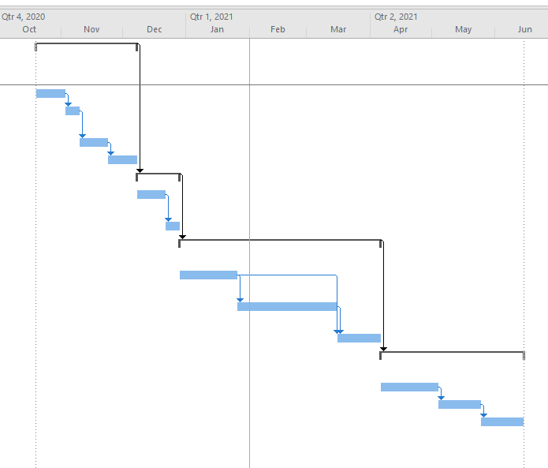

Project Gantt Chart

**Figure 3.7**

### **3.3 Experimental/ Simulation Setup**

The Experimental setup is comprised of both hardware and software.

* Hardware components include Laptops that are going to be used for the development of project and documentation, and printers are going to be used for printing stuff related to documentation that we have to submit.
* Software that will be used in the project includes:

1. PyCharm editor used for Django framework
2. Visual Studio Code for front-end development
3. Adobe XD for design of website
4. StarUML for designing UseCase, Sequence, Class diagrams.

### **3.4 Details of Work packages completed/milestones achieved**

Following is the list of work that has been achieved:

* **Location App**
* **Search Place**

User can search any place in the search bar, he will also get suggestions of places related to the word he is typing so that he can easily select any of the places he wants to get information of.

* **Featured Places**

Some of the places are displayed on the home page these are the featured places, these are shown on the basis of rating, places having high rating are displayed on home page.

* **Login via Google**

User has the option of logging in via google if he wants to add information about a new place or if he wants to rate any place, it is made easy for him to login via Gmail.

* **Add New Place**

If a user is logged in via Google, he has the option to add a place, he can add an image, name, description about the place and the place can be approved by the admin to be shown on the website. If the place is already present, that place could not be added.

* **Rate Places**

If a user is logged in via Google, he has the option to add a rating to the place, if he has already rated any place and try to rate again he will not be able to so, he can only rate one time on any place.

* **Place Information**

When a user searches for any place, he will get complete information about the place including distance of location from current location, map, images, related places, extra facilities.

* **Related Places**

Related places are shown when a user search for any city, all the places that are near to the searched location are displayed and user can explore them too.

* **Adventure Club App**
* **Search Event**

On the home page, user can search for any place and all the events that are occurring for that place will be shown.

* **Featured Adventure Clubs**

Some adventure clubs are shown on the home page, these are shown on the approval of admin, if he wants, he can show any of the club on home page as featured.

* **Featured Events**

Some events are shown on the home page, these are shown on the approval of admin, if he wants, he can show any of the events on home page as featured.

* **Ongoing Events**

In ongoing events, user can view all the events that are taking place or that are registered in Sayahat website, all events will be shown with their information such as start and end date and option to contact on WhatsApp.

* **User Registration**

If any user wants to register his clubs and events with Sayahat he will have to be registered on the website. He can create account here and add clubs and events.

* **Forgot Password**

If any user forgets his password, there is a feature to recover his account, he will have to write his email and on the basis of email, a link will be send to him from which he can set a new password for his account.

* **Manage Clubs**

User can manage his clubs if he is registered, he can add new clubs, delete registered clubs, edit any information regarding his registered clubs and view all his clubs.

* **Manage Events**

User can also manage his club events, if he is registered and want to add a new event for his club, he can add that, also he can modify the existing events such as changing the end date for any event.

### **3.5 Evaluation parameters**

Following are the parameters for our project evaluation:

* Project should be within budget
* Project should be completed within time constraint
* It should be easy to use
* Acceptance testing should be satisfied
* All the project requirements should be fulfilled
* All the features should be working perfectly
* There should be fewer errors in the website to make it efficient for use

# **Chapter 4**

## **Results and Discussion**

### **Simulation Results**

Following are given all the simulation results:

### **4.1.1 Website Testing**

We have done various testing techniques to test our website. Which includes:

• **Cross Browser Testing**

Tested the website on different browsers like Chrome and Internet explorer and check the behavior of website. No design or functionality issue raised during all of this.

• **Responsiveness**

Tested the website responsiveness by changing the screen size from Desktop to Tablet and Mobile. No design issue raised.

• **Reliability Testing**

Tested website reliability and it was reliable to all users.

• **Speed Testing**

Tested speed of website which gave awesome results.

• **Availability Testing**

When more number of users logged into the website, the website was available to all of them.

### **Product Demo**

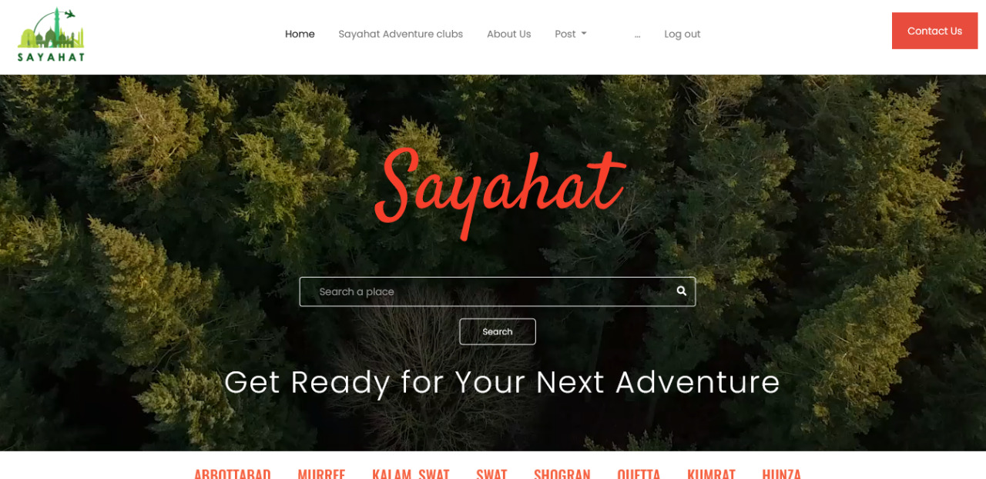

Search Bar-Home Page

**Figure 4.1**

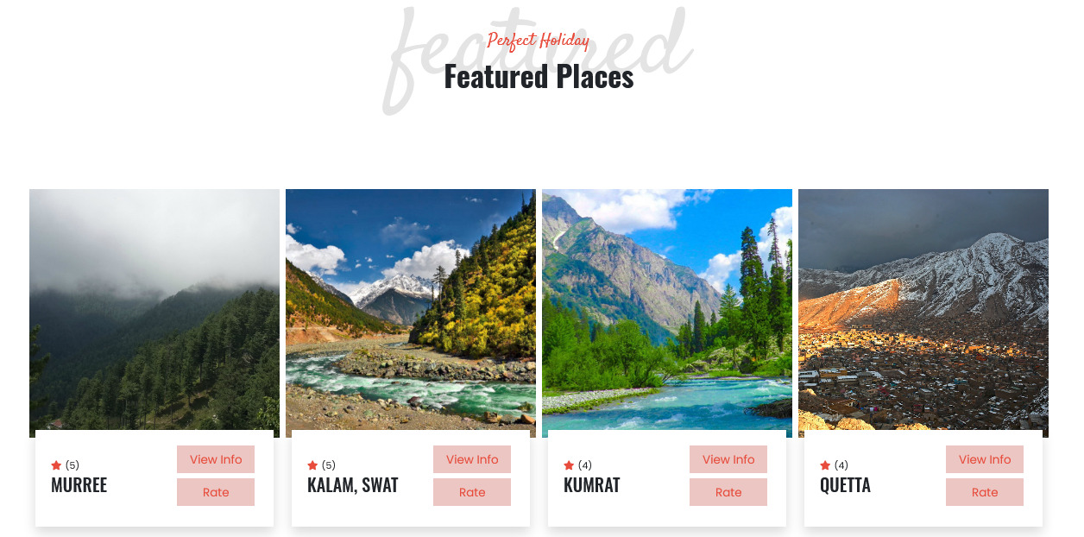

Featured Places

**Figure 4.2**

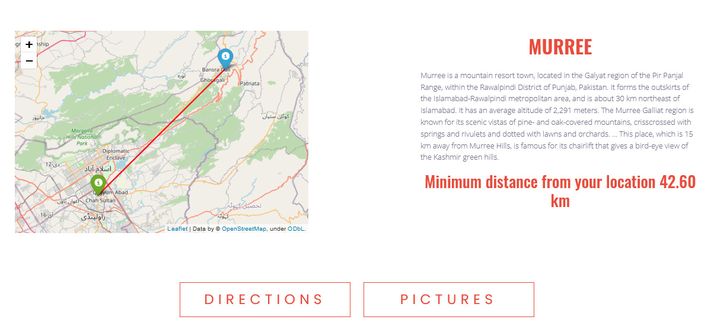

Place Information

**Figure 4.3**

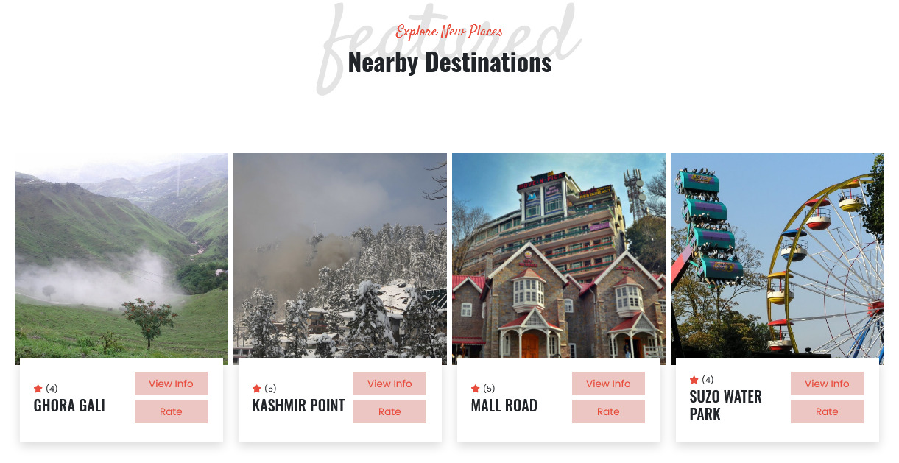

Featured Destinations

**Figure 4.4**

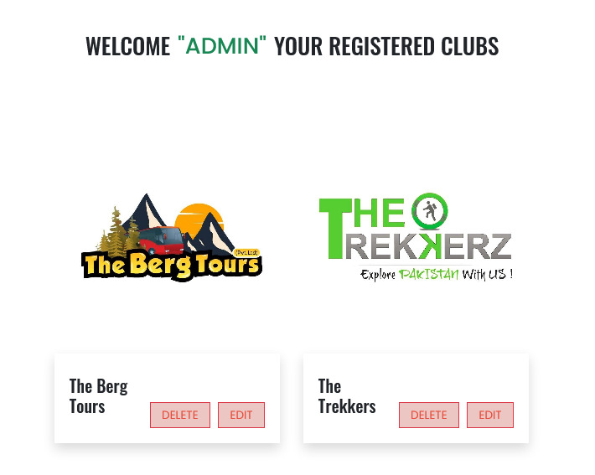

Registered Adventure Clubs

**Figure 4.5**

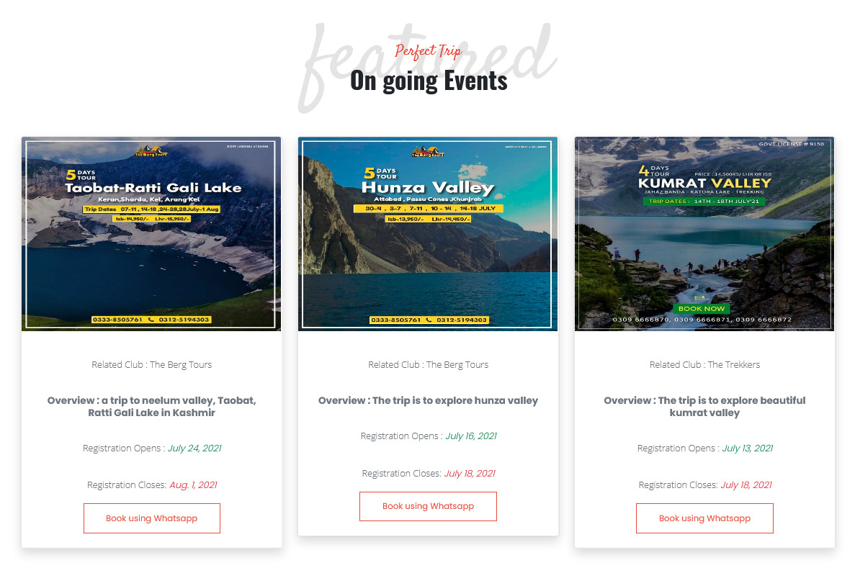

Ongoing Events

**Figure 4.6**

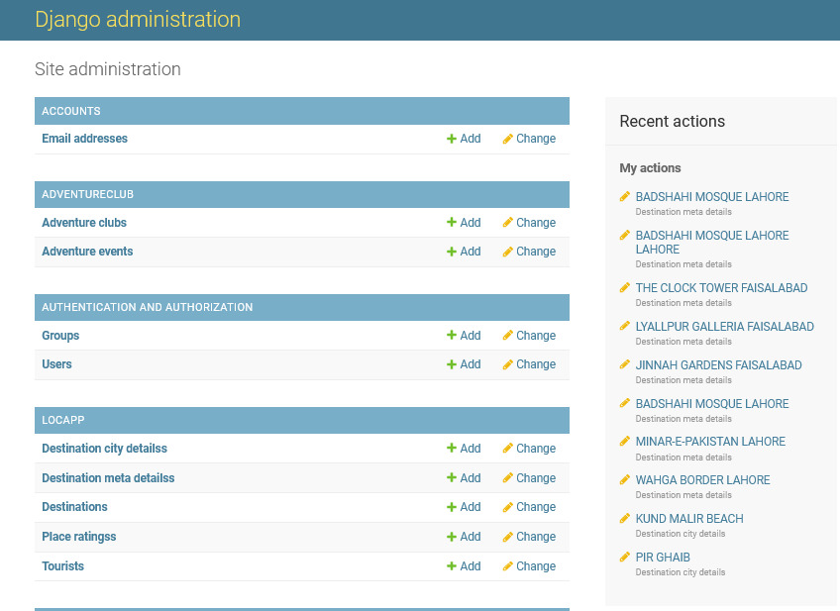

Admin Panel

**Figure 4.7**

### **Results Discussion**

In Sayahat, as there are two parts of web site, talking about the first one location app. Location app provide the feature to search for any location in the search bar, displays the featured places on home page on the basis of rating assigned by the users, blogs, provides complete details of each location including the map showing the path to reach at the destination. Also shows image of the location, description of the place, distance of that place from user’s location, related places to the searched location and also provide facility to get information about extra facilities available at these places like restaurants, petrol pumps, parks etc.

Talking about the adventure club app, search for any adventure club event, displaying featured adventure clubs. Adventure club owner can sign up to the website and also feature of forgot password is available, he can register his club and create events for his club. User can get complete information regarding the events conducted by these adventure clubs including their start date and end date. The adventure events get deleted after their start date passed.

### **Utilization (End users/Beneficiaries)**

The **Sayahat** web application is for two types of travelers:

1. Solo travelers
2. Group travelers

**Solo travelers:** This type of travelers are the ones who don’t want to go with stranger groups but want to travel at their own expense (Vehicle, own maps, etc), for example, family picnic plan for Nathiagali.

**Group travelers:** This type of people don’t want to take their vehicle but want to be a part of an adventure club group that would gather people and take them for a picnic or an expedition.

The website would have services for both types of travelers, the solo travelers would be provided with end-to-end maps services backed by Google Maps API.

They would also be provided essential information about the destination, route maps, weather conditions, and other relevant information.

Users who want to travel with an adventure club would be provided an option to register themselves and then book themselves for the trip.

Users would also be provided an option where they can leave a review (Stars) for the adventure club that they went with and we will use those reviews to show the clubs with the best services.

* **User Sign Up/Sign In**

We will provide 2 options for users to register with us. These options would be:

* Register with sayahat
* Login with Social login (Google/Facebook)

The businesses that want to register their adventure clubs with us would be required to register themselves, after registration they can create their Adventure clubs in the Sayahat web application and create events that travelers can book.

The users who just want to travel or go on a trip can just log in with their social media without registration from the start.

* **User booking**

Especially for the people who want to go with an adventure club would book the trip the process to book is:

1. Direct message to club WhatsApp handles
2. Using SMTP to send a mail notification to adventure club and then adventure club can reply with a confirmation of the booking through the email.
3. Payment can be through Jazz cash.

* **User Privacy**

There is a big concern of users that if they login with their social media how are they so sure that their data is not manipulated, to cover this concern of users we would buy a dedicated server just for the Sayahat web application and would include **SSL certification** to make out login and sessions transparent.

### **Budget Used**

We have developed a plan to market the Sayahat web application for public traffic once the website is ready and live.

* **Promotional Campaigns:**

We have developed a project marketing strategy to put Paid promotional campaigns on social media channels.

We will create new pages for the Sayahat web application and also put its promotional posts on our existing pages (Aaasan learning, Bawa party, DataTines).

Other than our assets we will put paid promotions on Facebook and Instagram for immense traffic on the website.

* **Dedicated server**

We plan to buy a dedicated server for the Sayahat web application, the purpose is t keep user login and registration transparency using SSL and for that, we need a dedicated server. So we would also have to buy a server through the budget.

* **Domain**

[www.sayahat.com](http://www.sayahat.com)

[www.sayahatPak.com](http://www.sayahatPak.com)

Any of the domains with the specification of word sayahat would also be bought to point to our server.

### **4.6 Market forecasting**

Pakistan has been blessed with all territories sating from the mighty Himalayas to deserts of thar and thal, dry mountainous Baluchistan and forever green pothwar plateau.

The Prime Minister of Pakistan Mr. Imran khan himself pays deep heed to tourism in Pakistan because he knows the potential in the revenue that can be generated through tourism in Pakistan.

The Pakistani Travel & Tourism industry had total revenues of $302.9bn in 2018, representing a compound annual growth rate (CAGR) of 7.4% between 2014 and 2018.

The Travel Intermediaries segment was the industry's most lucrative in 2018, with total revenues of $291.2bn, equivalent to 96.1% of the industry's overall value.

Pakistan is home to several UNESCO world heritage sites; some of the main tourist destinations in the country include Hunza Valley, Saiful Muluk Lake, and Naltar Valley.

Pakistan was ranked The Best Holiday Destination for 2020and was also declared the third-highest potential adventure destination in the world for 2020. As security in the country improves, tourism increases; in two years, it has increased by more than 300%. The Pakistani government has launched online visa services for 175 countries and 50 countries were offered visas on arrival, visiting Pakistan easier. The country received an influx of travel vloggers, who showed the beauty of the country, especially the northern areas Hunza and Skardu.

# **Chapter 5**

## **5.1 Conclusion**

Our tourism website will help all the tourists from Pakistan and around the globe to discover beautiful and hidden tourist spots in Pakistan that are rarely known, they can get all the information about those places including their location and guide to reach there. This will attract more tourists towards Pakistan as they have the problem of finding different spots or destinations because there is no active website in Pakistan that helps tourists to have information about the majority of fantastic places in Pakistan. In this way we can promote tourism which is a great financial asset for our country.

## **5.2 Prospects**

We can buy a domain for Sayahat and deploy it in future. We can add more features in the existing website and collaborate with google AdSense so that it can be a great source of income for us and for our country by attracting more tourists in Pakistan. Further we can also extend this idea by developing a mobile application for Sayahat that would be great and more handy for the users. Further we can allow the users to add blogs so that they can share their experiences with all other users of Sayahat. Moreover, we can add functionality for the adventure clubs to handle their payments in Sayahat by adding payment gateways. There is a lot of scope of such a website in Pakistan.

# **6. References**

1. <https://eurasiantimes.com/pakistan-ranked-the-best-holiday-destination-for-2020-by-leading-travel-magazine/>
2. <https://gulfnews.com/world/asia/pakistan/pakistan-tops-list-of-worlds-best-travel-destination-for-2018-1.2148655>
3. <https://www.forbes.com/sites/annabel/2018/12/12/the-10-coolest-places-to-go-in-2019/?sh=643925b1fdc5>
4. <https://www.dawn.com/news/1325829>
5. <https://www.wttc.org/-/media/files/reports/economic-impact-research/countries-2017/pakistan2017.pdf>
6. <https://www.geo.tv/latest/323663-pakistans-tourism-industy-is-seeing-an-unprecedented-boost-pm-imran-khan>